Customer Shopping Behaviour Analysis
1. Project Overview
This project analyses customer shopping behaviour using transactional data from 3,900 purchases across various product categories. The goal is to uncover insights into spending patterns, customer segments product preferences and subscription behaviour to guide strategic business decisions
2. Dataset Summary
- Rows: 3.900
- Columns: 18
- Key Features:
- Customer demographics (Age, Gender, Location, Subscription Status)
- Purchase details (Item Purchased, Category, Purchase Amount, Season, Size, Colour)
- Shopping behaviour (Discount Applied, Promo Code Used. Previous Purchases, Frequency of Purchases, Review Rating, Shipping Type)
- Missing Data: 37 values in Review Rating column
3. Exploratory Data Analysis using Python
We began with data preparation and cleaning in Python
- Data Loading: Imported the dataset using pandas.
- Initial Exploration: Used df.info() to check structure and df.describe() for
summary statistics.
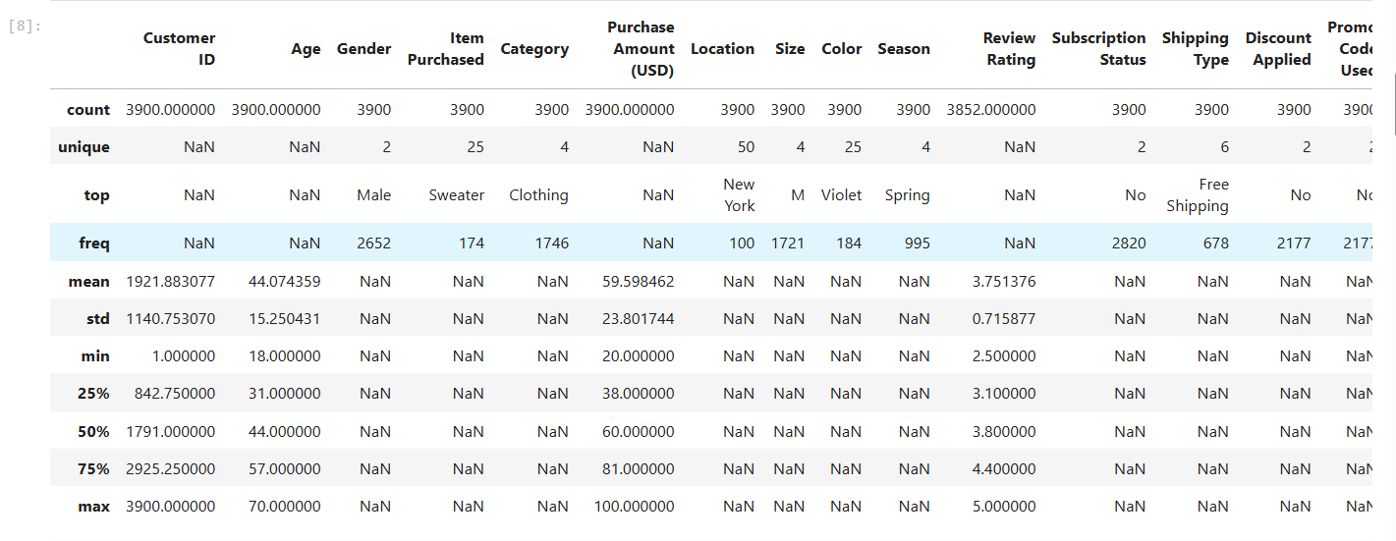
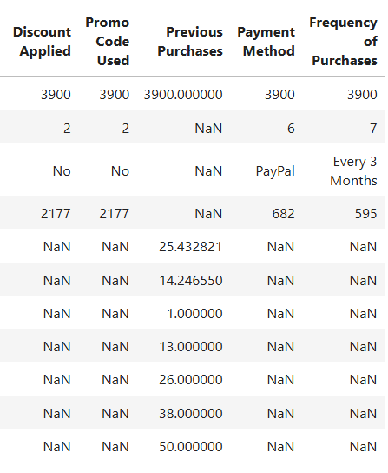

- Missing Data Handling: Checked for null values and imputed missing values in the Review Rating column using the median rating of each product category.

- Column Standardization: Renamed columns to snake case for better readability and documentation.

- Feature Engineering:
Created age_group column by binning customer ages.
Created purchase_frequency_days column from purchase data.

- Data Consistency Check: Verified if discount_applied and promo_code_used were redundant, dropped promo_code_used.

Database Integration: Connected Python script to MYSQL and loaded the cleaned Data Frame into the database for SQL analysis
4. Data Analysis using SQL (Business Transactions)
We performed structured analysis in PostgreSQL to answer key business questions
1. Revenue by Gender - Compared total revenue generated by male vs female customers
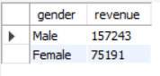
2. High-Spending Discount Users - Identified customers who used discount but still spent more than average purchase amount.
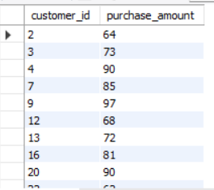
3. Top 5 Products by Rating - Found products with the highest average review rating.
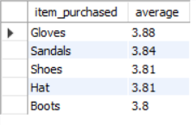
4. Shipping Type Comparision - Compared average purchase amounts between standard and express shipping.
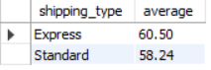
5. Subscribers Vs Non Subscribers - Compared average spend and total revenue across subscription status.
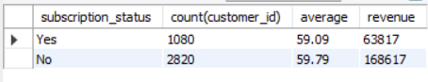
6. Discount-Dependant Products - Identified 5 products with the highest percentage of discounted purchases.
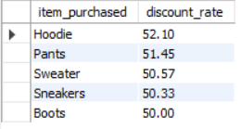
7. Customer Segmentation - Classified customers into New, Returning and Loyal segments based on purchase history.
